**Security**

**Adding JWT token validation in ASP.NET Core Web API**

1. Create new .NET Core Web API project.
2. Add a new controller to the project eg: **MovieController**
3. Add the **Authorize** attribute to the controller class

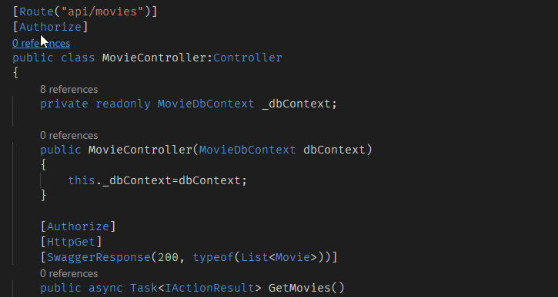

1. Now we need to add JWT authentication to the project add the JWTBearer package to the project.

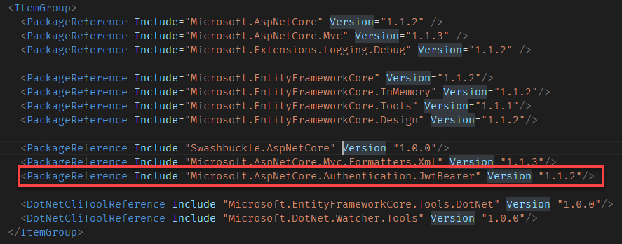

1. Add two classes to represent the Authentication Request and response.

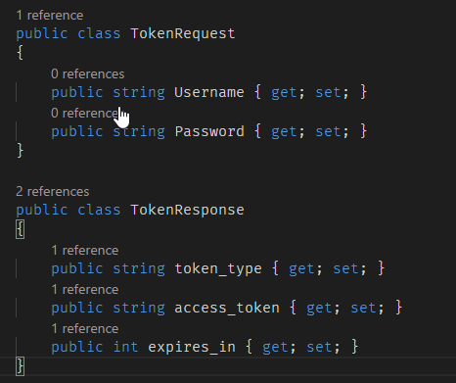

1. Create a new folder Options in the root folder and add a class to the folder named “TokenOptions”.

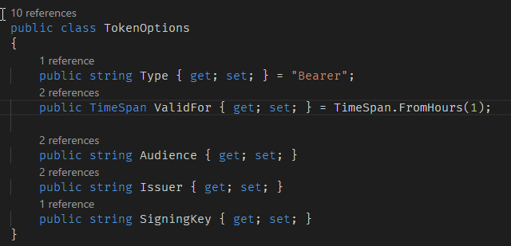

1. Now we need to add some extension methods to the TokenOptions class. Create a subfolder “Extensions” inside the “Options” folder and create a class inside the folder.

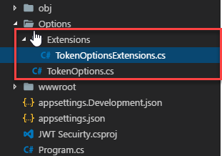

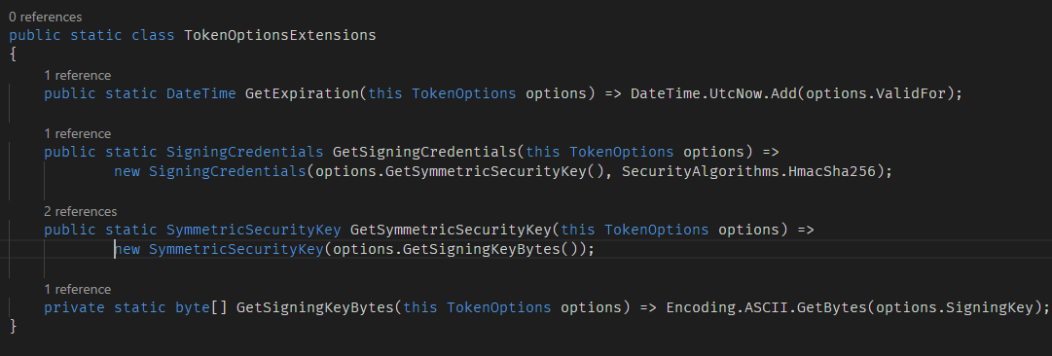

1. Now add the Topne Options configuration to the appsettings.json file.

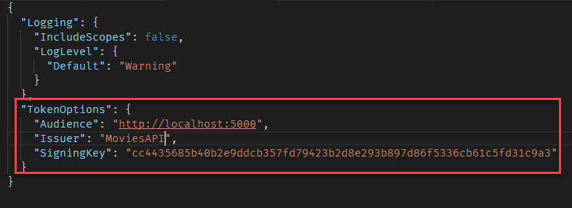

1. Add an authentication controller to the project.

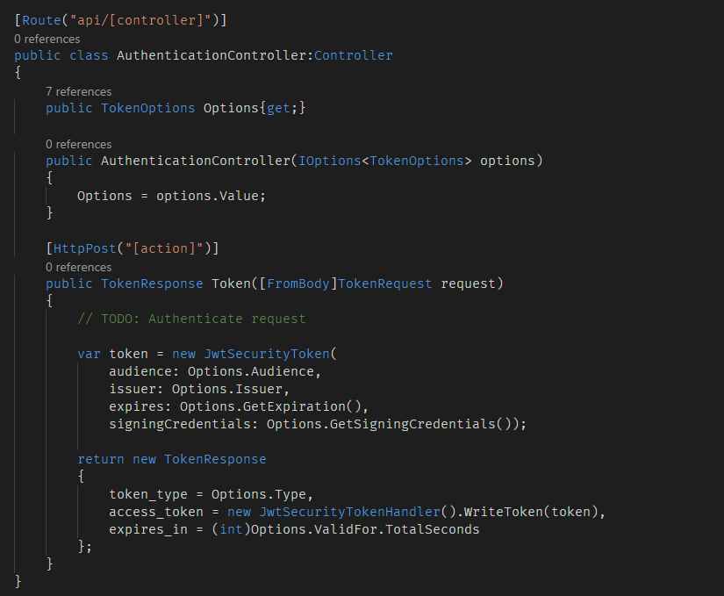

1. Add the following codes to the ConfigureServces method in Startup class.

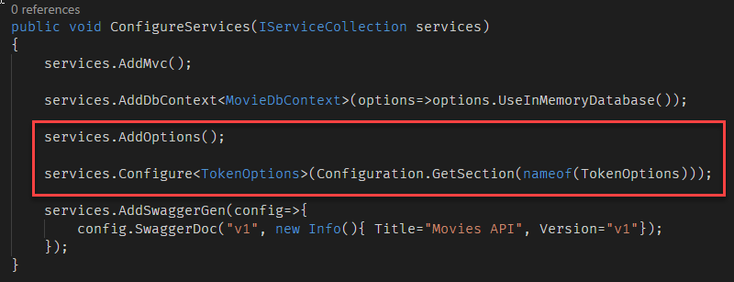

1. Add the JWT authentication middleware in the Configure method of startup class

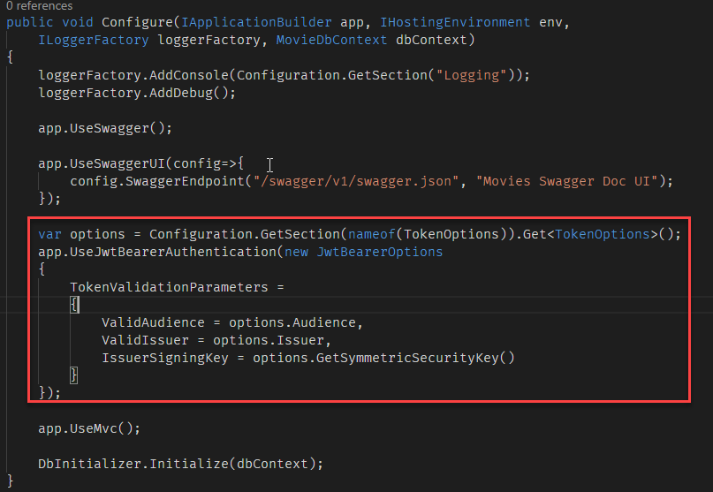

1. Restore all packages and run the project
2. To test the API, open POSTMAN applications and send a **POST** request to the **Token** method of the **Authentication** controller to get the access token. Send the user name and password in the request body to generate the access token.

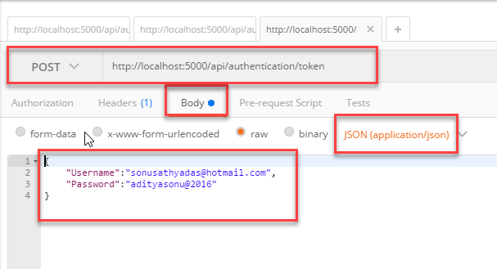

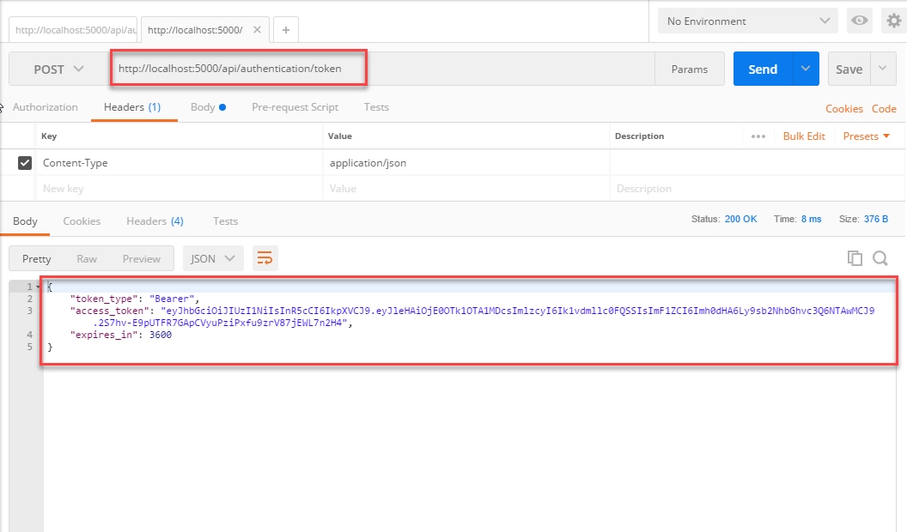

1. You can use the Access token to consume the API,

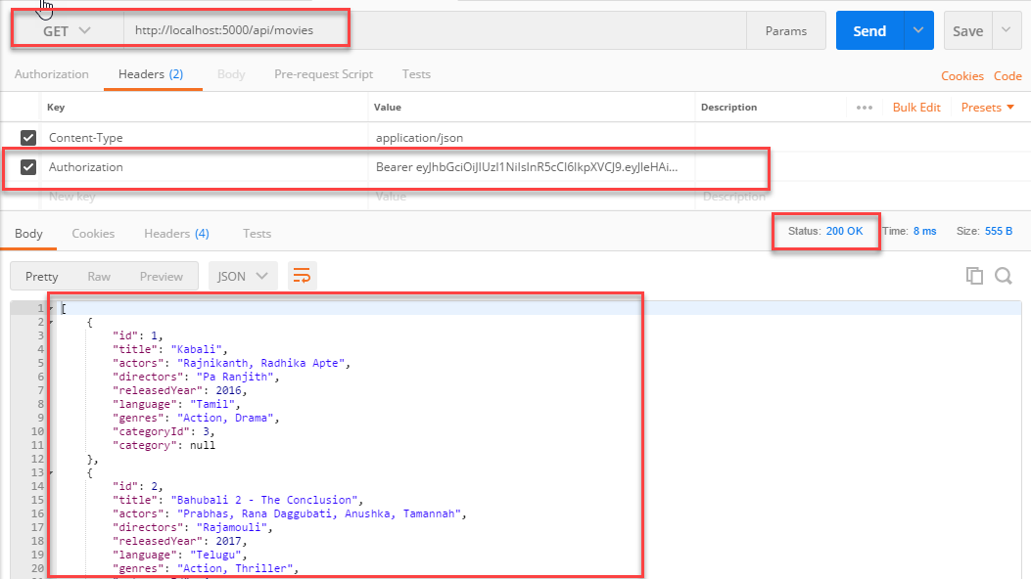

1. You can also test without the authentication token. It returns 401 (Unauthorized)

